**PWM Module Description Document**

**1.Introduction**

The AP80 series chips provide 8 PWM output channels, namely PWM0 to PWM7. Each channel has 2 selectable mapping PAD pins, and each PAD port can output via a pull-down current source or directly without a pull-down current source. The module clock is designed based on a 12MHz clock and is not affected by system clock down-conversion. The relationship between frequency and duty cycle is shown below, where FreqDiv is the division ratio, Duty is the set duty cycle, and the range is 0–100%:

PWM frequency = 12MHz / FreqDiv;

High-level duty cycle = Duty/FreqDiv * 100%;

1. **Main Performance**

* Supports 8-channel PWM output simultaneously, with no interference between channels;
* Each PWM channel has 2 PAD pin options;
* Supports 4 output modes: direct output, 1.7mA pull-down current output, 2.4mA pull-down current output, and 4.1mA pull-down current output;
* Based on a 12MHz clock, unaffected by system clock down-conversion;
* PWM frequency supports up to 6MHz;
* PWM duty cycle supports 0~100%;

**3. Configuration Process**

1. Enable PWM Function

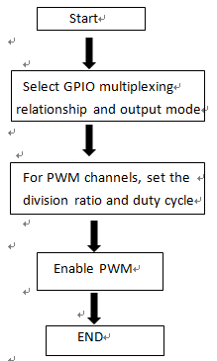

Figure 1 PWM Usage Configuration

2. Exit PWM Function

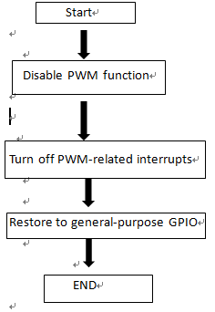

Figure 2 Disable PWM Configuration